**Sayem Chowdhury**

**CSE 2110: Computer Science I**

**Programming Project**

**Subject: Short Description of Design Planning and General Comments.**

**Date: 12/03/2017**

**Short Description of Design Plan**

In my design plan I derived both classes newcar type and oldcar type from the base class car type. As show in the diagram below:

**car Type**

**oldcar Type**

**newcar Type**

**UML design diagram of the car Type class:**

The UML design diagram of the car type class will showing all the private and public members of the car type class below:

|  |
| --- |
| **car Type** |
| -VIN string  -make string  -model string  -year int  -price float  -category string |
| + operator<< (ostream& , const vector<car>&): ostream&  + operator<< (ostream& , const car&): ostream&  + car(string, string, string, int, float, string )  +set_VIN(string ) :void  +set_make(string):void  +set_model(string ):void  +set_year(int ) :void  +set_price(float ):void  +set_catagory(string):void  +get_VIN( ): string  +get_make():string  +get_model():string  +get_year( ):int  +get_price():float  +get_catagory():string  +virtual print():void |

The function print is a virtual function and overridden for both of the derived classes.

**UML design diagram for newcar Type class:**

The UML design diagram of the newcar type class will showing all the private and public members of the newcar type class below:

|  |
| --- |
| **newcar Type** |
| -nc_warrenty string |
| +operator<< (ostream& , const newcar&): ostream&  +newcar(string, string, string, int, float, string, string)  +print():void |

car type

newcar type

**UML diagram for the oldcar type class:**

The UML design diagram of the car type class will showing all the private and public members of the car type class below:

|  |
| --- |
| **oldcar Type** |
| -nc_warrenty string |
| +operator<< (ostream& , const newcar&): ostream&  +newcar(string, string, string, int, float, string, int)  +print():void |

car type

oldcar type

After designing the based and derived class I created a vector object of the pointer of car type in the user program. Using the default constructor of the of the type and oldcar type I created oldcar and newcar object and put in those newcar and oldcar objects in the vector object.

**Vector Object:**



**I also created and implemented following functions in the user program:**

The function **convert_string** will convert user input to uppercase letter.

The function **addCar** will add the car in the inventory.

The function **catalog123** will display the catalog.

The function **Search_D_Inventory** will give the three search option search by category, search by make, and search by model

The function **sell_car** will give the option to the user for sell/lease the car.

The function **returnCar** will return old or a new car to the inventory.

The functions **print_data_into the_file** will print the car data into the file.

Also, **function read_data_from_file** will read data from the file and will display the car data to the user.

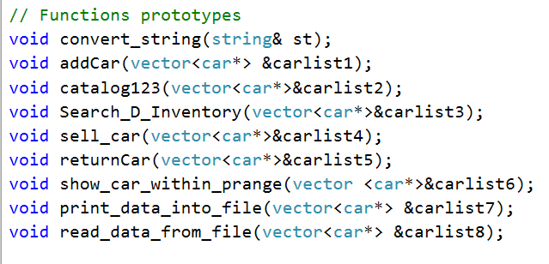

By calling those function in the main function of the program I completed necessary operation to fulfill the project requirements.